**Candle LED Bulb**

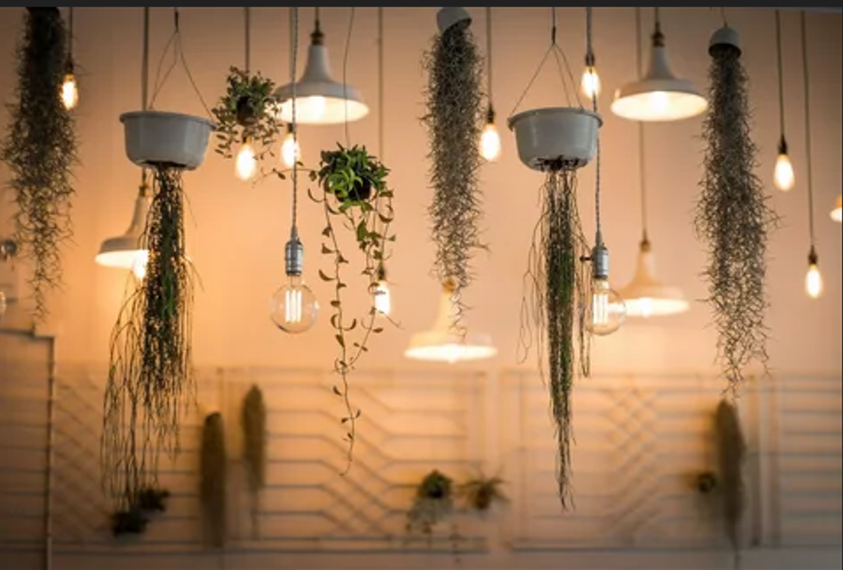

#### ****Description:****

**Candle LED Bulbs** are elegant, energy-efficient lighting solutions designed to mimic the shape of a traditional candle flame. These bulbs are perfect for chandeliers, wall sconces, and decorative fixtures where the bulb itself is visible. With a warm, inviting glow, Candle LED Bulbs add a touch of sophistication to any space.

* **Technology:** LED.
* **Compatibility:** Standard E12 (candelabra base) or E26/E27 base (depending on the model).
* **Bulb Type:** B11 (candle shape), CA10 (candelabra shape).
* **Wattage:** 4W (equivalent to 40W incandescent), 6W (equivalent to 60W incandescent).
* **Lumens:** 400 lumens (4W), 600 lumens (6W).
* **Color Temperature:** 2700K (warm white), 3000K (soft white).
* **Dimmable:** Yes (select models).
* **Lifespan:** 25,000 hours.
* **Energy Efficiency:** Energy Star certified.

#### ****Key Features:****

* **Elegant Design:** Mimics the shape of a traditional candle flame, perfect for decorative fixtures.
* **Energy-Efficient:** Uses up to 85% less energy than traditional incandescent bulbs.
* **Warm and Inviting:** Provides a cozy, warm white light for a relaxing ambiance.
* **Dimmable Options:** Available in dimmable models for adjustable brightness.
* **Long Lifespan:** Lasts up to 25,000 hours, reducing the need for frequent replacements.
* **Versatile Use:** Suitable for chandeliers, wall sconces, and decorative lamps.

#### ****Pricing:****

* **Single Bulb (4W, B11):** $9.99
* **Single Bulb (6W, CA10):** $12.99
* **4-Pack (4W, B11):** 34.99(34.99(8.75 per bulb)
* **4-Pack (6W, CA10):** 44.99(44.99(11.25 per bulb)

#### ****Where to Use:****

* **Chandeliers:** Add a touch of elegance to your dining room or entryway.
* **Wall Sconces:** Provide soft, warm light for hallways and living spaces.
* **Decorative Lamps:** Enhance the ambiance of your bedroom or living room.
* **Restaurants and Cafes:** Create a cozy and inviting atmosphere for customers.
* **Retail Stores:** Highlight products with stylish and functional lighting.

### ****Customer Reviews:****

* ⭐⭐⭐⭐⭐ "These Candle LED Bulbs are stunning! They add so much character to my chandelier. The light is soft and warm, perfect for my dining area." – Sarah L.
* ⭐⭐⭐⭐ "Great value for the price. The bulbs are beautiful, and the light is very warm and inviting. Highly recommend for anyone looking to add a touch of elegance to their space." – James T.
* ⭐⭐⭐⭐⭐ "I love how energy-efficient these bulbs are. The candle shape is a bonus!" – Emily R.

### ****How to Order:****

1. Visit our website: [www.brightworldlighting.com](http://www.brightworldlighting.com/)
2. Select your preferred bulb type and pack size (Single or 4-Pack).
3. Add to cart and proceed to checkout.
4. Enjoy free shipping on all orders over $50!

### ****Warranty and Support:****

* **Warranty:** 2-year limited warranty covering manufacturing defects.
* **Customer Support:** Contact us at [support@brightworldlighting.com](mailto:support@brightworldlighting.com) or call +1-800-123-4567 for assistance.